**Physical Design**

**Ground floor layout**

1 Computer

Projector

6 Computers

Cables

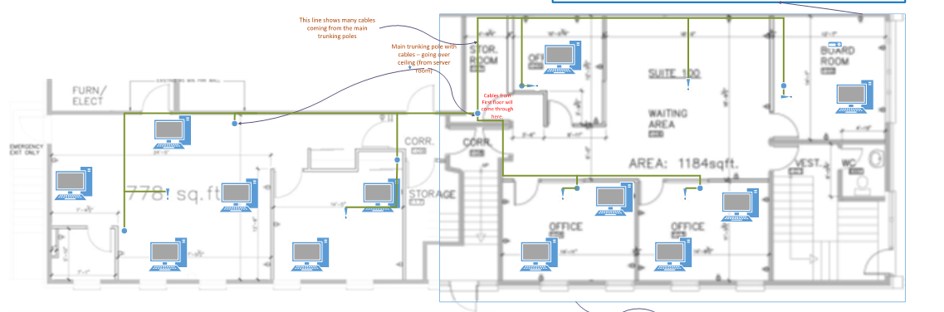

Trunking pole

1 Computer symbol = Group of 6 computers organized

by 1 switch, except in the board rooms where it is only 1.

Group of workstations

Wifi gateway

**Boardroom layout**

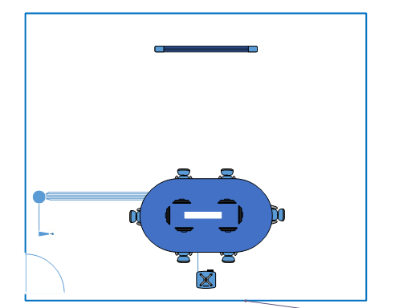

Workstation

Cables

Trunking pole

Wifi gateway

Projector and smartboard equipment

**Offices layout**

Trunking pole

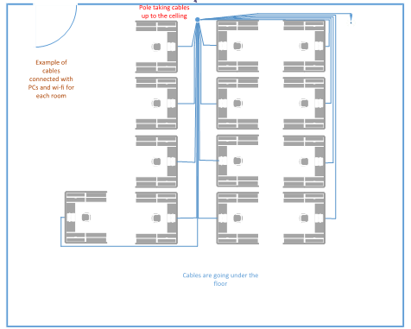

Cables

Wifi gateway

Workstation

**Server room layout**

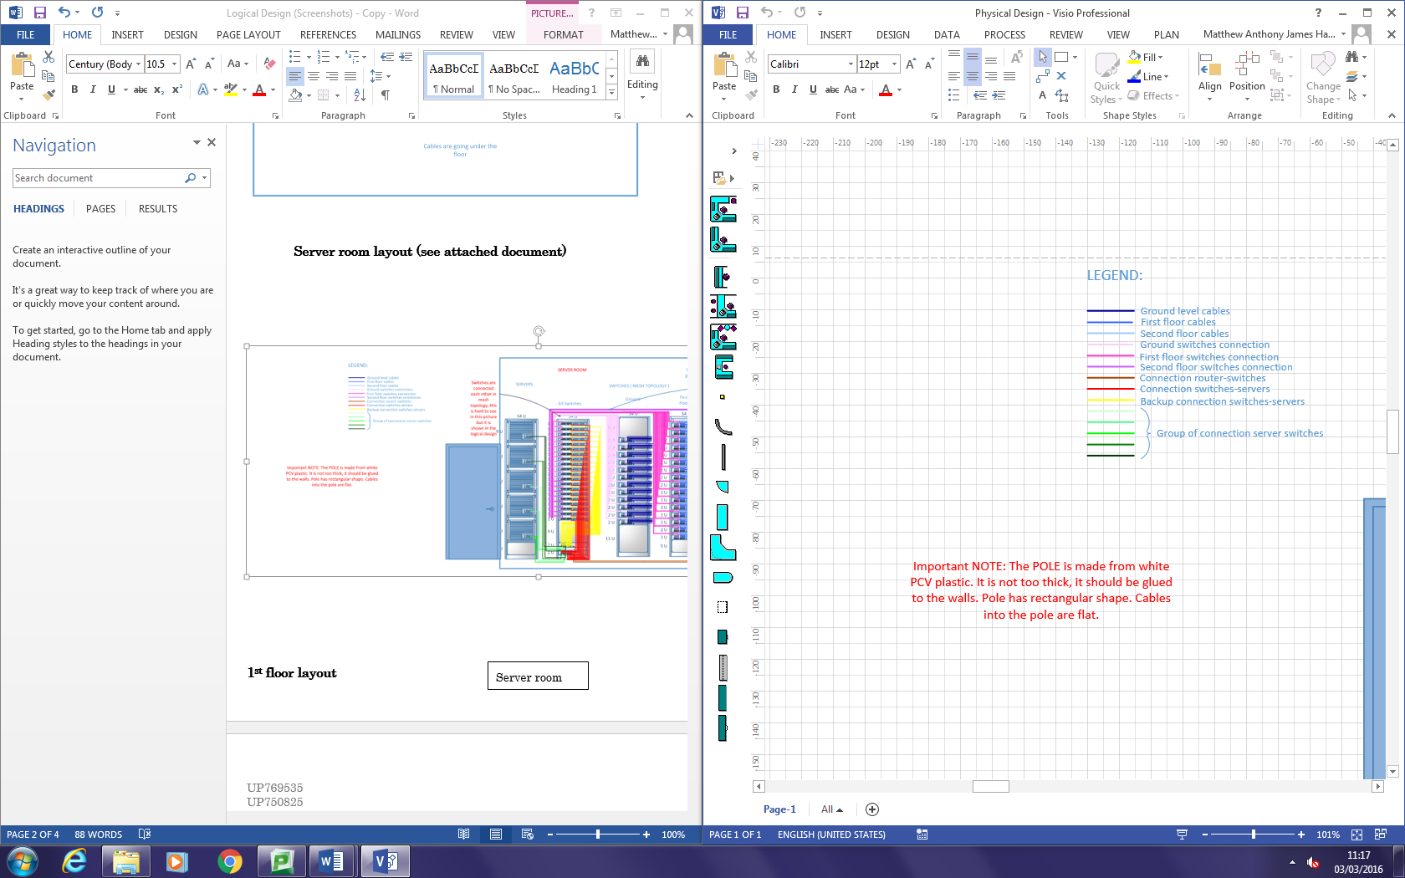

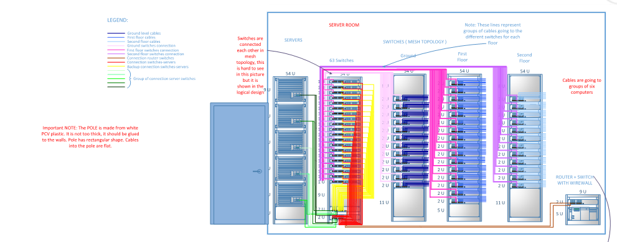

**1st floor layout**

Server room

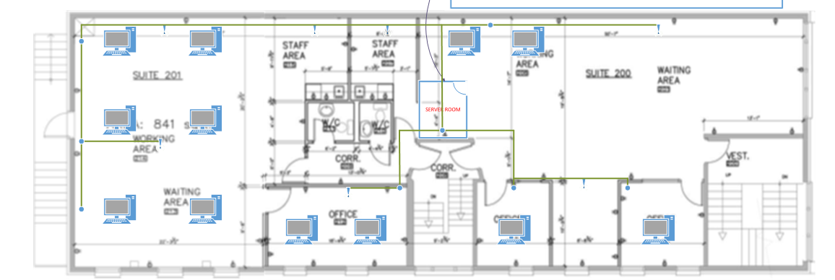

**1st floor working area layout**

Workstation

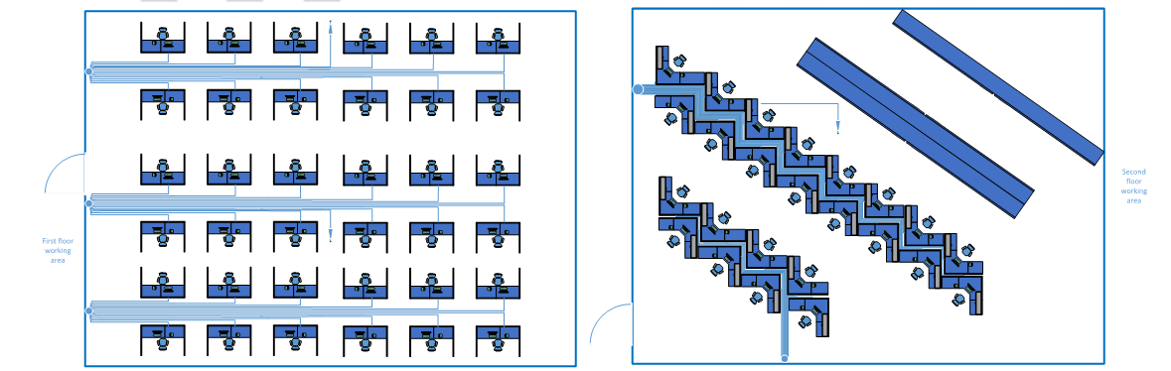

**2nd floor layout**

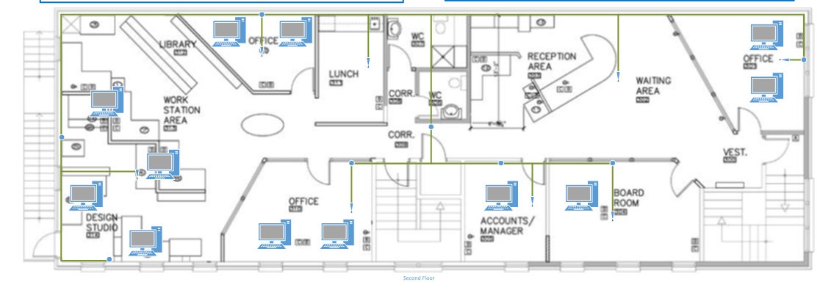

1 PC

**2nd floor working area layout**

Workstation

